Synopsis of the March, 2016 North Louisiana Flood Event

North Louisiana and adjacent areas of south Arkansas and eastern Texas experienced a record setting flood event during the week of March 8-12. Rainfall totals in excess of 24 inches occurred during the event across portions of north-central Louisiana, much of which fell over a three-day period. The excessive rainfall produced immediate and widespread flash flooding, some of which was unprecedented, followed by more long-term lake, river, and bayou flooding.
The winter months prior to the event gave little indication of what was about to come. December, 2015 saw warmer than average temperatures and slightly above normal rainfall. The monthly temperature average was 56.6 degrees, 8.4 degrees above normal. Precipitation was 6.39”, 1.10” above normal. The first 12 days of December saw little in the way of precipitation; however, several rain events exceeding one-inch were recorded on the 13th (1.61”), 16th (1.32”), 21st (1.43”), and 25th (1.62”).
January, 2016 was rather uneventful weather wise. The average monthly temperature was 45.9 degrees, 0.6 degrees below normal, and the monthly rainfall was 4.72”, 0.29” below normal. Two events in January produced rainfall in excess of one-inch: 21st (1.84”) and on the 26th (1.29”).
February temperatures averaged 53.0 degrees, 2.5 degrees above normal. Rainfall was 2.69”, 1.94” below normal. Only two rain events in excess of one-inch occurred during the month. 1.03” fell on the 15th and 1.43” fell on the 22nd and 23rd (0.49” and 0.94” respectively).
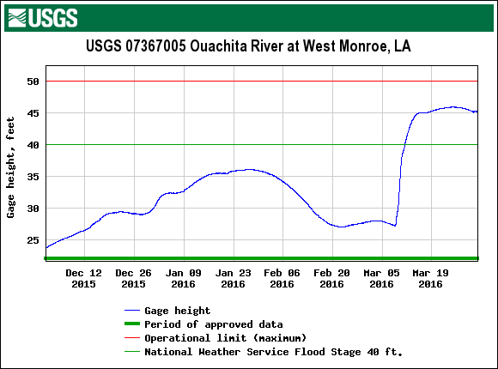
River stages on the Ouachita River at Monroe/West Monroe (see adjacent chart) were at relatively normal levels leading up to the flood event. Levels had peaked at around 36ft in late January in response to above normal rainfall in December, 2015 but had fallen to near 27ft during the first week of March, 2016. Had the river been near or above flood stage prior to the event, the outcome would likely have been far worse given that river levels rose nearly 18 feet in only a few days.
The flood was categorized by some experts as a 1000-year flood event and at a minimum was a 500-year event. Flood classification as a 100, 500, or 1000-year flood is based upon probability, not actual occurrence. A 100-year flood, for example, means that a given event has a 1-in-100 chance that it will occur in a given year. Likewise a 500-year flood has a 0.2% chance and a 1000-year flood a mere 0.1% chance in a given year.
Computer models indicated a potential heavy rainfall event across the south-central portion of the country at least five days in advance; however, the amount and exact location remained uncertain. The initial Qualitative Precipitation Forecast (QPF) from the Weather Prediction Center indicated the heaviest rainfall amounts would be across eastern Arkansas. As the event approached, models shifted the highest totals southwestward across east Texas and western Louisiana. Predicted seven-day totals ranged from 10 to just over 12 inches. In the end, the heaviest rainfall axis shifted east across north-central Louisiana where predicted totals were woefully underestimated.
A Flash Flood Watch was issued for all of north Louisiana Thursday afternoon, March 7. At the time, forecast rainfall for the event, as stated in the watch bulletin (NWS-Shreveport), was much less than what actually fell and the target area was initially for northeast Texas, northwest Louisiana, and southwest Arkansas.

PERIODS OF HEAVY RAINFALL CAN BE EXPECTED OVER MUCH OF THE AREA WEDNESDAY AS THESE SHOWERS AND THUNDERSTORMS SLOWLY SPREAD EAST...WITH ADDITIONAL REDEVELOPMENT EXPECTED WEDNESDAY NIGHT AND THURSDAY ESPECIALLY OVER EXTREME EASTERN TEXAS...NORTH LOUISIANA...AND SOUTHWEST ARKANSAS. WIDESPREAD RAINFALL AMOUNTS OF THREE TO SIX INCHES ARE EXPECTED THROUGH THURSDAY AFTERNOON...WITH ISOLATED HIGHER AMOUNTS UP TO NINE INCHES POSSIBLE ESPECIALLY OVER EXTREME EASTERN TEXAS...WESTERN LOUISIANA...AND SOUTHWEST ARKANSAS.

Subsequent Flash Flood Watch updates over the course of the next 24-48 hours increased potential rainfall amounts while shifting the heavy rainfall axis to the east.
The event began to unfold during the early morning hours of Tuesday, March 8. A strong upper level low at the 500mb level was evident over the northern Baja Peninsula as part of a deep dip in the jet stream across that area. At the surface, a 1028mb high was located off the southeastern US coast with developing low pressure across western Oklahoma. Rich moisture funneled into east Texas and Louisiana ahead of the Oklahoma front and a new area of low pressure and stationary front that had formed over east-central Texas. The strong surface high off the southeast US coast along with upper level ridging effectively blocked movement of the system eastward. Over the next five days, the 500mb jet would continue to plunge well into Mexico slowly taking the upper low with it. Repeated disturbances rounded the upper low and pushed into east Texas and Louisiana resulting in a copious stream of moisture and excessive rainfall over the next three days.
Heavy rainfall from the first surge of strong thunderstorms began across the Toledo Bend region of the state as well as northeast and east Texas around 1900Z (1PM) on the afternoon of March 8. These storms spread north-northeast producing very heavy rainfall. By 2200Z (4PM), the line was encroaching upon north-central Louisiana stretching from near Homer to Arcadia to Jonesboro. A few of the storms reached severe intensity producing localized wind damage. A new line formed across northeast Texas and southwestern Arkansas and began to move into northwestern Louisiana. It was this second line that prompted the first flash flood warning of the event.
Flash flooding began within just a few hours of the onset of rain across northwestern Louisiana, quickly spreading to north-central Louisiana and adjacent areas during the late afternoon and evening hours of March 8. The first Flash Flood Warning was issued by the NWS-Shreveport office at 4:55 PM (2255Z), March 8 for Caddo, Bossier, Webster, DeSoto, western Claiborne, northwestern Red River, and west-central Bienville Parishes. Bossier City recorded 5.42” of rain in a four-hour period (2PM-6PM). By 8 PM, nearly all of northwestern Louisiana north of a Farmerville to Ruston to Natchitoches to Anacoco line was under a Flash Flood Warning. Flash Flood Warnings for Ouachita and Caldwell Parishes, as well as the remainder of Union Parish were issued at 9:35 PM on March 8 essentially placing all Louisiana parishes west of the Ouachita River under a Flash Flood Warning.
During the early morning hours of March 9, flash flooding from earlier thunderstorms was ongoing; however, rain intensity had briefly diminished. Unfortunately, another disturbance triggered a fresh round of very heavy rainfall and additional flooding. The 1200Z radar (6AM) indicated developing thunderstorms from Monroe westward to near Tyler, Texas. A north/south oriented line that was over northeast Texas entered northwestern Louisiana at 1330Z. The line pushed east with individual storms moving north and northeast within the line. By 1600Z the line was pushing into central Union and western Ouachita Parishes, extending southwestward to near Winnfield and Leesville. The line did not advance much farther to the east before stalling allowing storms to train over the same areas.
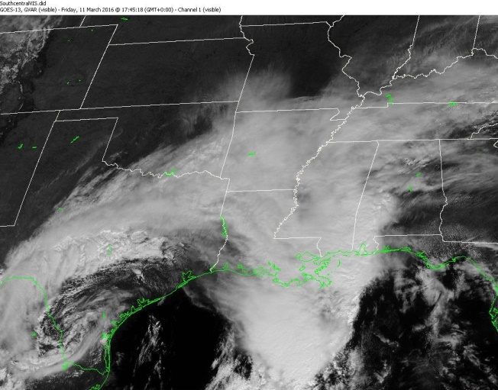
On March 10 a surface low developed off the central Texas coast in response to the upper low moving northeast out of Mexico. The surface low occluded over south Texas on the 11th (see satellite image). The entire system finally ejected out of the area on March 12 and 13 ending the record-setting flash flooding event. Unfortunately, area lakes, rivers, and bayous continued to feel the effects of the heavy rainfall throughout the remainder of March.
Rainfall totals for the period of March 8 through March 12 exceeded 10-inches across most of north Louisiana. With one exception in Union Parish (Rocky Branch 1.3W) all reported amounts in excess of 20-inches fell in Ouachita Parish. Some locations immediately adjacent to Ouachita Parish likely received 20 or more inches but no recording stations were in those areas. The highest total was in north Monroe where a CoCoRaHS station reported 26.96 inches. The rainfall totals were so excessive in north-central Louisiana, the Ouachita River north of Monroe began to flow north for a short period of time.

Storm Totals for Ouachita Parish and Rocky Branch (Union Parish) 03/08/2016-03/13/2016

Station Name | Total Precip Inches
Monroe 3.2 SSE | 26.96
Monroe 1.9 NNW | 24.93
Monroe 2.4 WNW | 24.22
West Monroe 10.1 SW | 23.50
Swartz 2.0 SSW | 23.33
Delta Community College | 21.97
Monroe Regional Airport | 21.29
Calhoun 4.3 SSE | 20.96
Monroe 5.5 ENE | 20.81
Monroe 2.5 NNW | 20.53
Rocky Branch 1.3 W | 20.29

*Map courtesy of NOAA/National Weather Service

Daily 500mb and Surface Maps

Select Radar Images
Below are radar images mentioned in the event review.

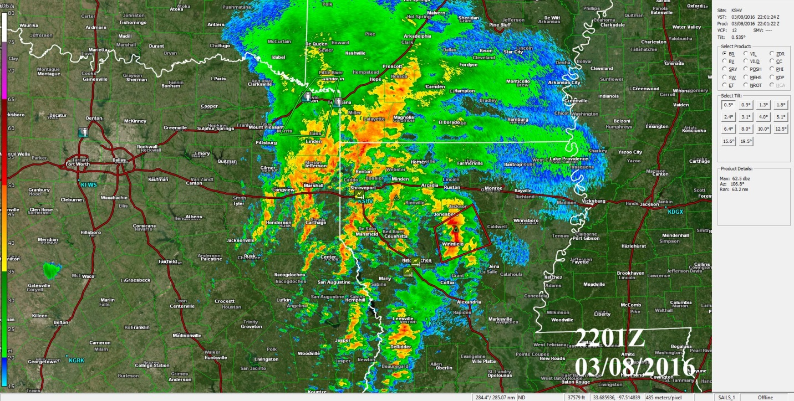
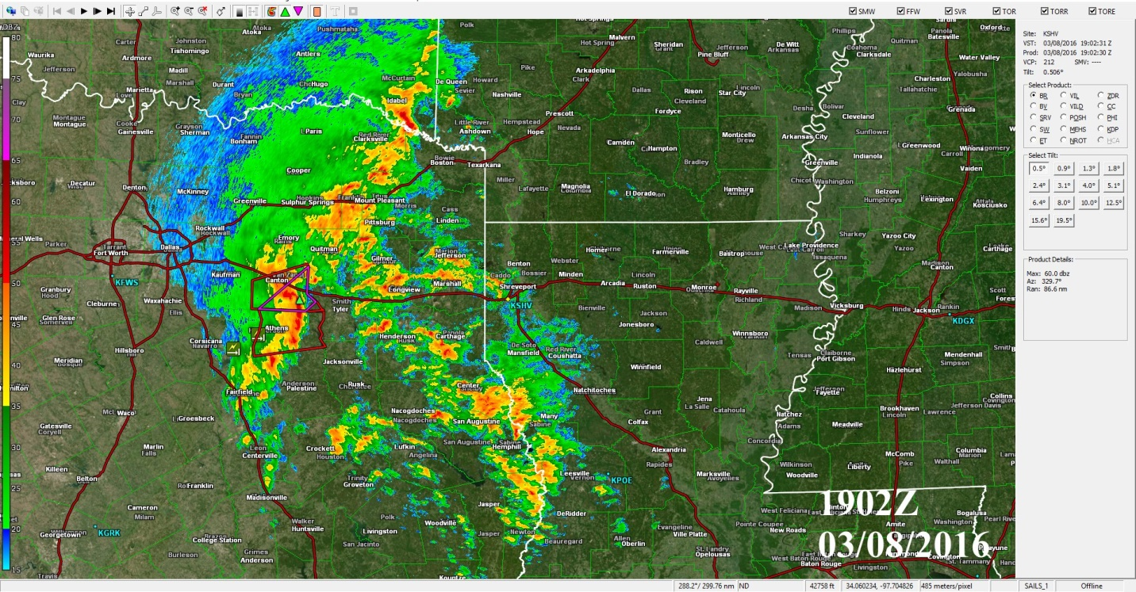

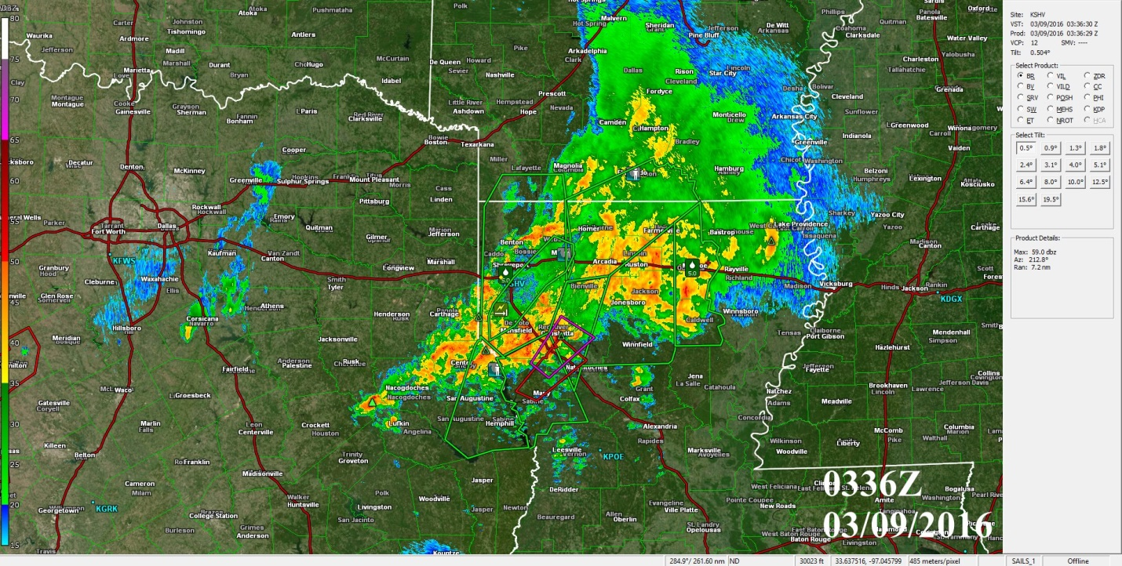
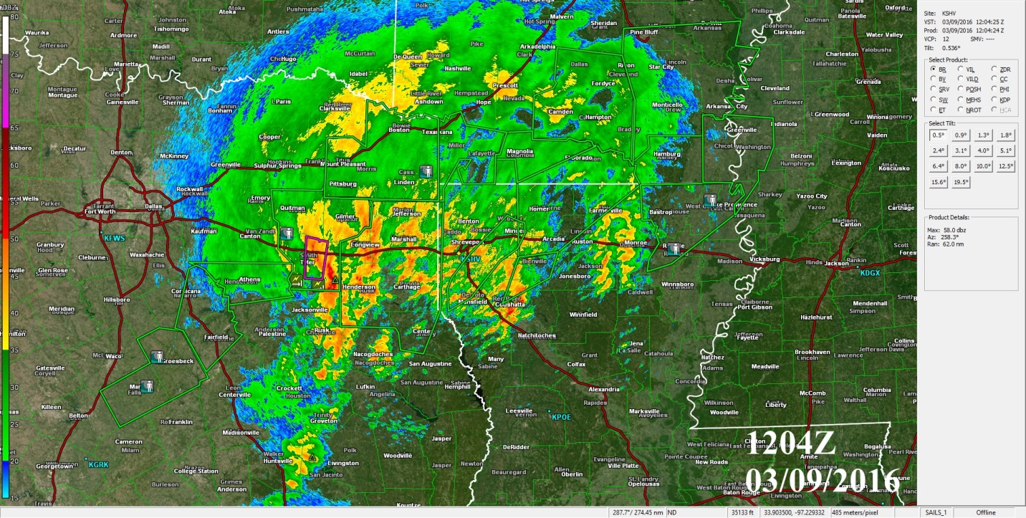
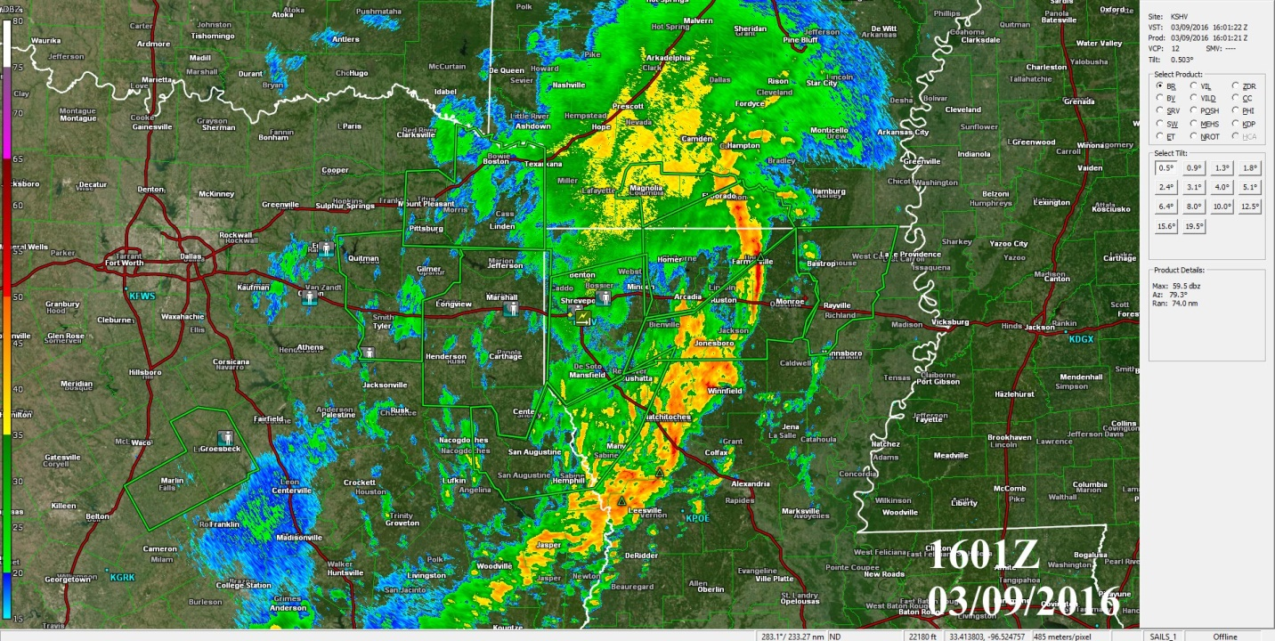

Select North Louisiana Rainfall Totals 03/08/2016-03/13/2016

Station Name | Total Precip Inches
Monroe 3.2 SSE | 26.96
Monroe 1.9 NNW | 24.93
Monroe 2.4 WNW | 24.22
West Monroe 10.1 SW | 23.50
Swartz 2.0 SSW | 23.33
Delta Community College | 21.97
Monroe Regional Airport | 21.29
Calhoun 4.3 SSE | 20.96
Monroe 5.5 ENE | 20.81
Monroe 2.5 NNW | 20.53
Rocky Branch 1.3 W | 20.29
Minden 2.0 NE | 18.20
Ruston 5.5 NNW | 18.02
Minden 2.2 NE | 17.92
Ruston 1.6 NW | 17.53
Bienville 0.5 S | 17.46
Natchitoches 0.9 NE | 16.86
Natchitoches 4.8 WNW | 16.12
Bossier City 2.4 WNW | 15.98
Pioneer 0.3 WSW | 15.50
Pleasant Hill 10.2 SE | 15.41
Bossier City 3.0 S | 15.28
Homer 1.2 N | 15.25
Shreveport 5.3 SSE | 14.86
Columbia 4.1 NNW | 14.77
Shreveport 3.4 ENE | 14.70
Shreveport 6.7 S | 14.43
Shreveport 3.2 ESE | 14.40
Coushatta 1.4 NE | 14.21
Shreveport 6.2 S | 14.00
Bossier City 6.7 NNW | 12.67
Keithville 1.5 NNW | 12.46
Bossier City 8.2 NNW | 11.80
Keithville 4.2 WNW | 11.01
Plain Dealing 3.3 ESE | 10.79
Plain Dealing 3.0 ESE | 10.70
Winnsboro 5.3 NNE | 10.18
Monticello 3.0 ENE | 7.21

